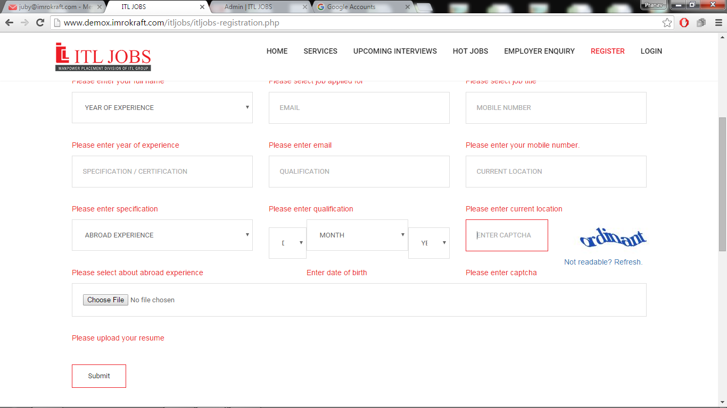

1 .Correctly align dob field in registration form when no datas are entering in the field.Please refer the above screenshot

2. Change the page heaing to ‘list of resumes’ instead of ‘list of admins’ while redirecting from the tab ‘List Resumes’

3. Unable to delete admin from superadmin

4. Unable to add admin with the mail id that previously created (but the admin is not in thelist)

5. Linking hot jobs and interview pages with user side (design according to itljobs current website)

6. **Admin: Can’t** update the sorting number of job list

7. **Admin: Unable** to change password in admin panel

8. Need to view admin name to know who will schedule in job listing and interviewing list

9. 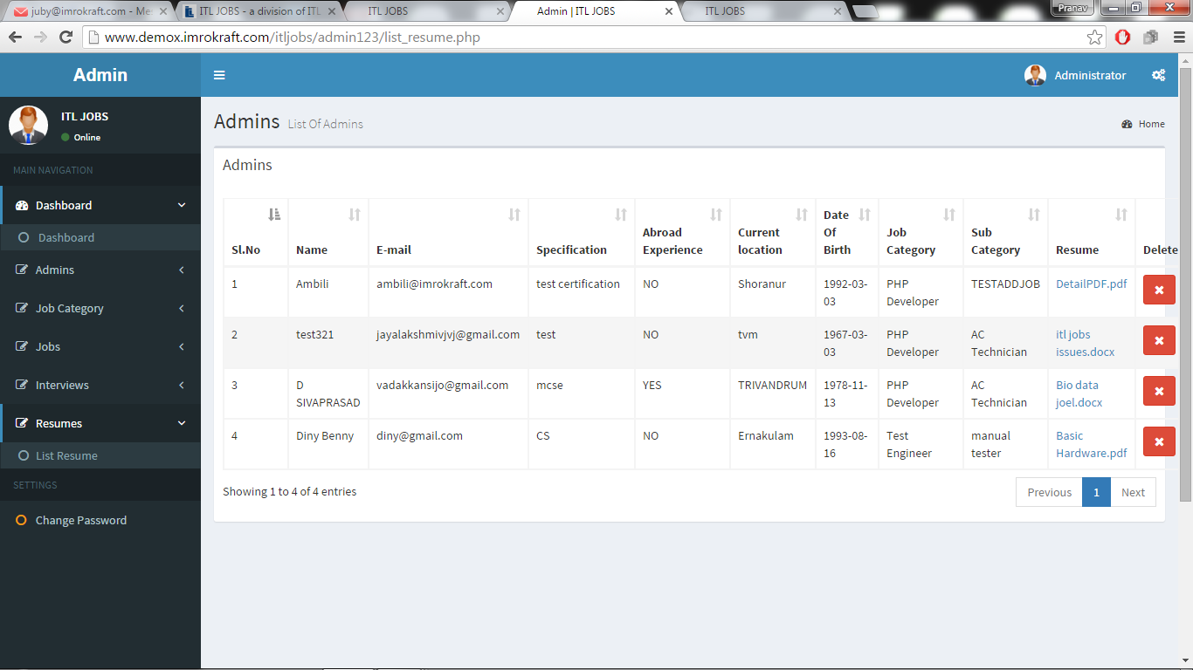

Need to align the table admin list in super admin

10.Session need to be implemented in super admin